MODULE 4
Analysis of Species-wise Bird Migration Behaviour
Data Preprocessing – II using WEKA
Aim:
To perform basic data preprocessing operations such as Discretization, Feature Selection using WEKA and Orange tool.
Data Preprocessing using WEKA
Step 1: Load Dataset
Open Weka and load dataset by going to the "Preprocess" tab and clicking on "Open file." Choose the file format of dataset (e.g., ARFF, CSV) and select the dataset file from file system.
Step 2:
Explore Data Before applying any preprocessing techniques, it's essential to understand data. Use the "Visualize" option to explore statistical summaries, histograms, scatterplots, etc., to get insights into the distribution of data and identify any potential issues.
Step 3:
Apply Preprocessing Techniques Step 3.1:
Data Discretization Select the Discretize Filter:
In the "Preprocess" panel, locate the "Filter" section, then scroll down and find the "unsupervised.attribute" category. Within this category, you'll find the "Discretize" filter. Click on it to select it.
Apply the Discretize Filter:
Drag and drop the "Discretize" filter onto the pipeline area in the "Preprocess" panel.
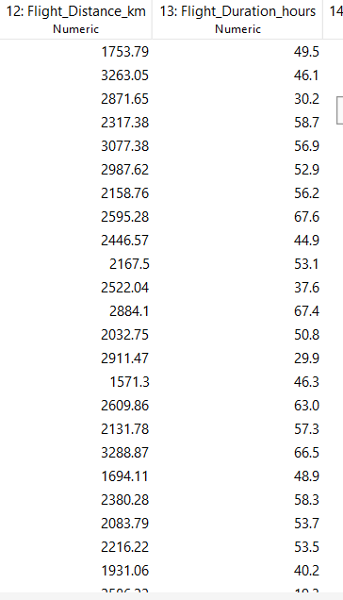
Fig no 4.1.Before Discretization

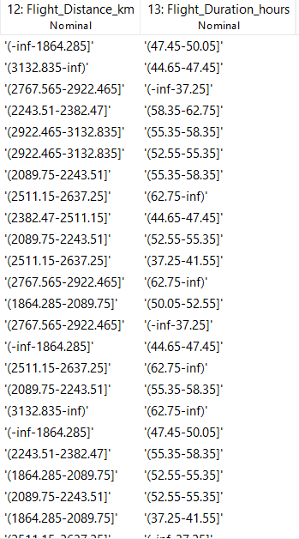
Fig no 4.2.After Discretization

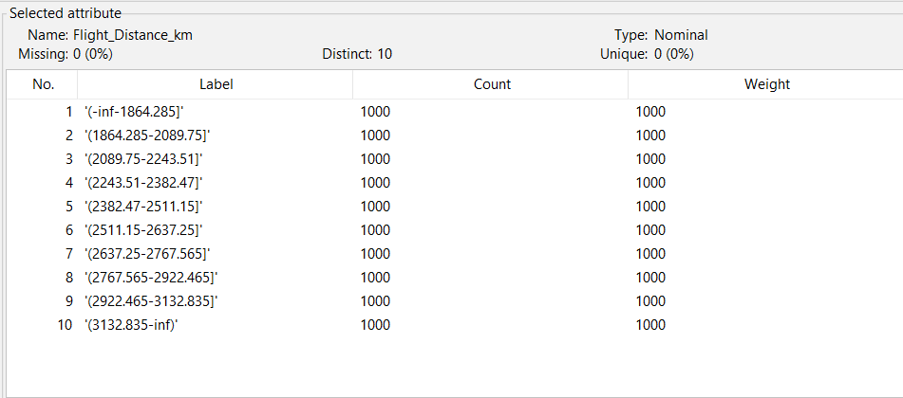
Fig.no.4.3 Statistics of Discretized attributes(Flight_Distance)
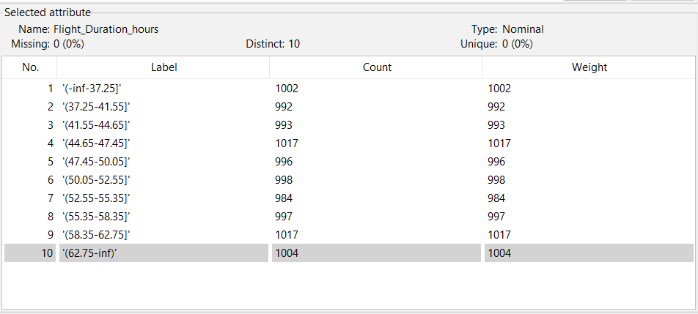
Fig.no.4.4 Statistics of Discretized attributes(Flight_Duration)
Configure Discretization Options:
After adding the "Discretize" filter to the pipeline, click on it to configure its parameters. Specify which attributes want to discretize by selecting them from the list of attributes. Weka offers various discretization methods, such as equal-frequency, equal-width, supervised, and unsupervised.
Choose the method that best suits your data and objectives. Adjust any additional parameters specific to the chosen discretization method, such as the number of bins or intervals

Apply the Filter:
Once you've configured the discretization options, click on the "Apply" button to apply the filter to your dataset.
The discretized dataset will be displayed in the "Preprocess" panel.
Step 3.2:
Data – Feature Selection Select the AttributeSelection Filter:
In the "Preprocess" panel, locate the "Filter" section, then scroll down and find the "unsupervised.attribute" category. Within this category, you'll find the "AttributeSelection" filter. Click on it to select it.
Apply the AttributeSelection Filter:
Drag and drop the "AttributeSelection" filter onto the pipeline area in the "Preprocess" panel.
Configure Feature Selection Options:
After adding the "AttributeSelection" filter to the pipeline, click on it to configure its parameters. You can specify which attributes you want to select or deselect by selecting them from the list of attributes.
Weka offers various feature selection algorithms, such as BestFirst, GreedyStepwise, or Ranker, CfsSubsetEval, InfoGainAttributeEval, and ReliefFAttributeEval. Choose the algorithm that best suits your data and objectives. Adjust any additional parameters specific to the chosen feature selection algorithm, such as the number of selected features or evaluation metrics.
Apply the Filter:
Once you've configured the feature selection options, click on the "Apply" button to apply the filter to your dataset. The dataset with selected features will be displayed in the "Preprocess" panel.

1. Which destinations are most frequently used by each bird species, and what common factors explain these preferences?
Target: End_Latitude, End_Longitude
Supporting: Species, Region, Habitat, Weather_Condition, Migration_Reason
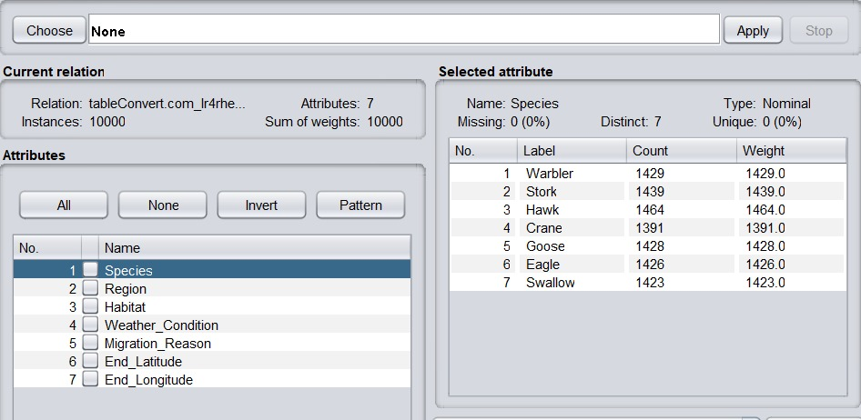
Fig no.4.5 Before applying Attribute Selection for destination visited frequently

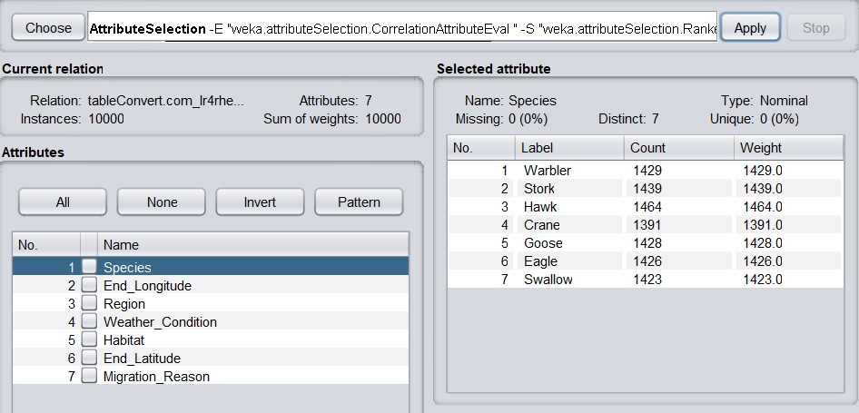
Fig no.4.6 After applying Attribute Selection for destination visited frequently

2. What are the primary reasons behind successful bird migrations across different species?
Target: Migration_Success
Supporting: Migration_Reason, Species, Weather_Condition, Habitat
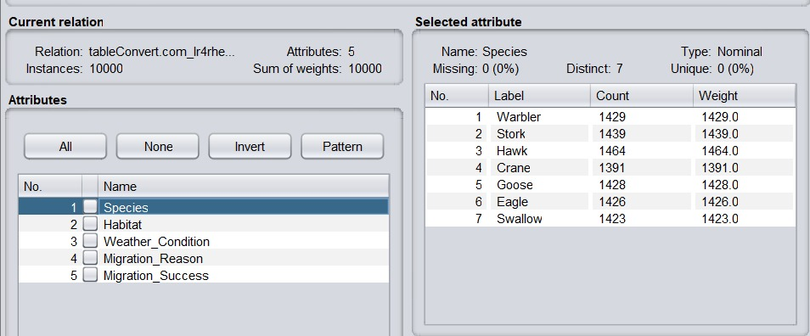
Fig no.4.7 Before applying filter for primary reason for migration
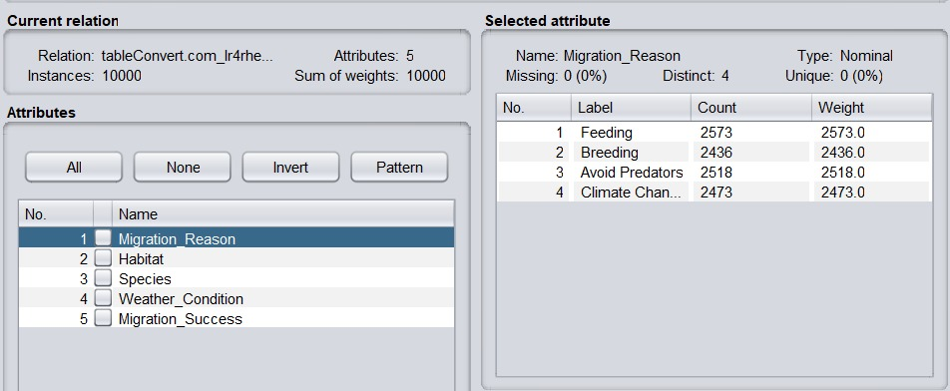
Fig no.4.8 After applying filter for primary reason for migration

3. What factors most often lead to migration failure among birds?
Target: Migration_Success (Failure cases), Migration_Interrupted
Supporting: Interrupted_Reason, Weather_Condition, Habitat, Species
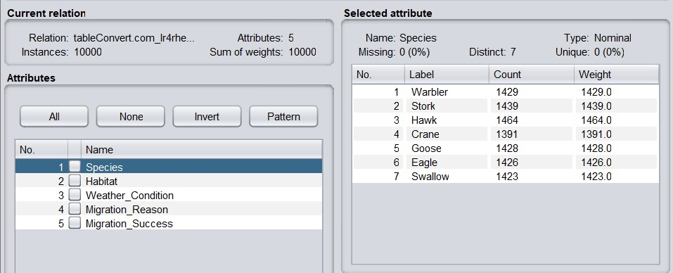
Fig no.4.9 Before applying filter for factors leadind to migration failure
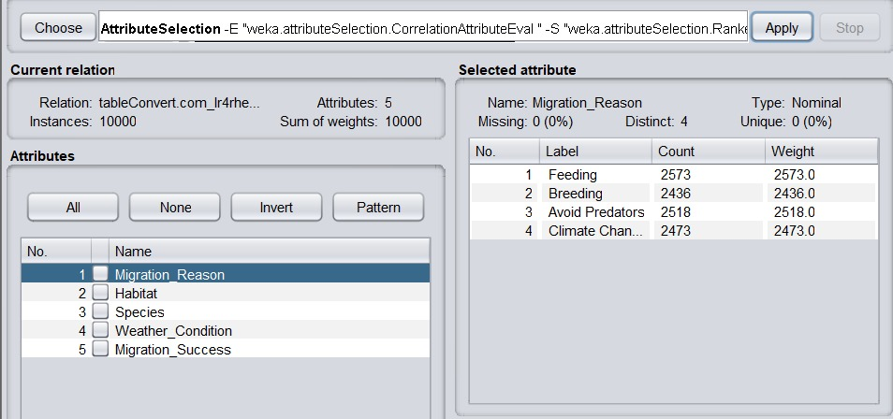
Fig no.4.10 After applying filter for factors leadind to migration failure

4. How does migration distance influence the success rate of bird migrations?
Target: Migration_Success
Supporting: Start_Latitude, Start_Longitude, End_Latitude, End_Longitude, Flight_Distance_km
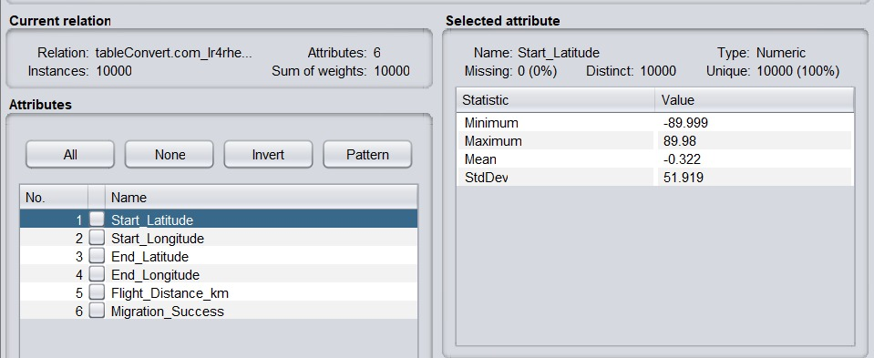
Fig no.4.11 Before applying filter for migration distance influence the success rate of bird migrations
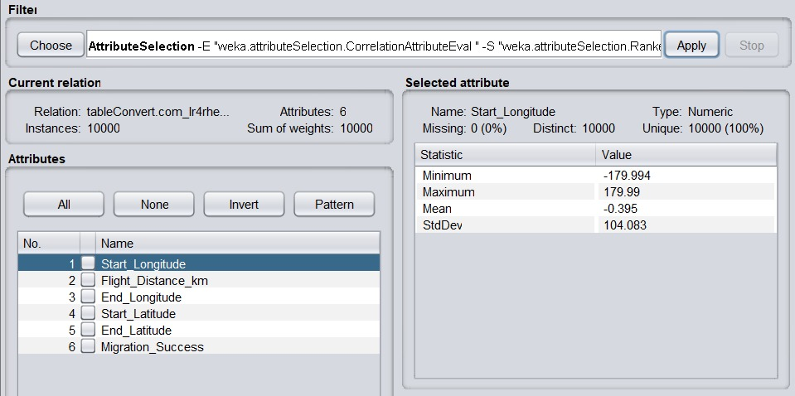
Fig no.4.12 After applying filter for migration distance influence the success rate of bird migrations

5. Which bird species show the most consistent migration routes over time?
Target: Start Latitude & End latitude
Supporting: Species, Year, Start_Latitude, Start_Longitude, End_Latitude, End_Longitude
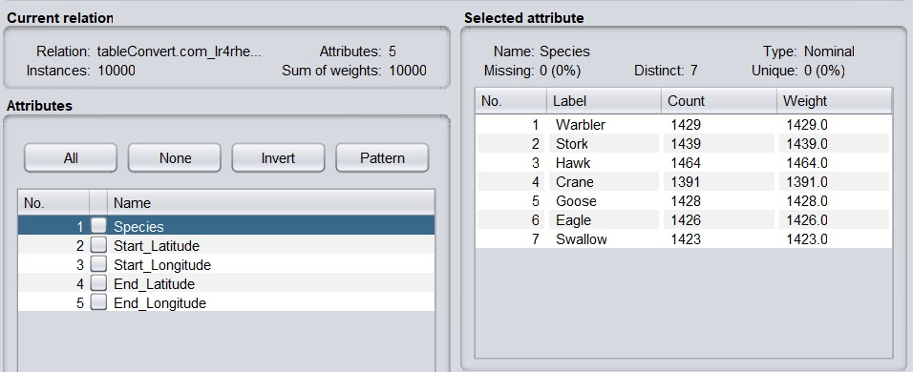
Fig no.4.13 Before applying Attribute Selection for the most consistent migration routes
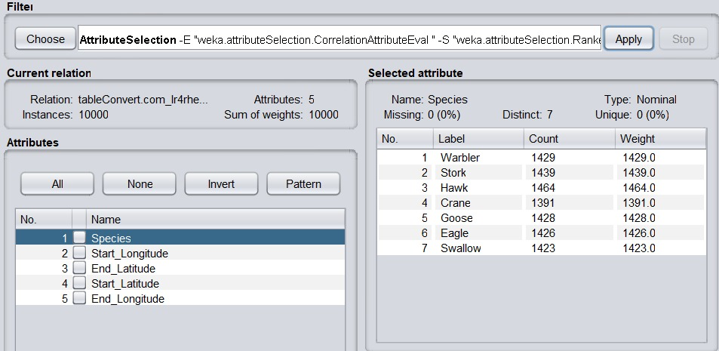
Fig no.4.14 After applying Attribute Selection for the most consistent migration routes

6. Which regions act as major migration hubs for multiple bird species?
Target: Region
Supporting: Species, Start_Latitude, Start_Longitude, End_Latitude, End_Longitude
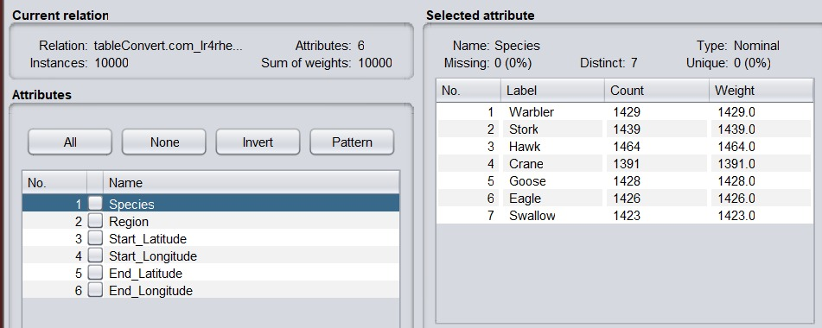
Fig no.4.15 Before applying Attribute Selection for major migration hubs
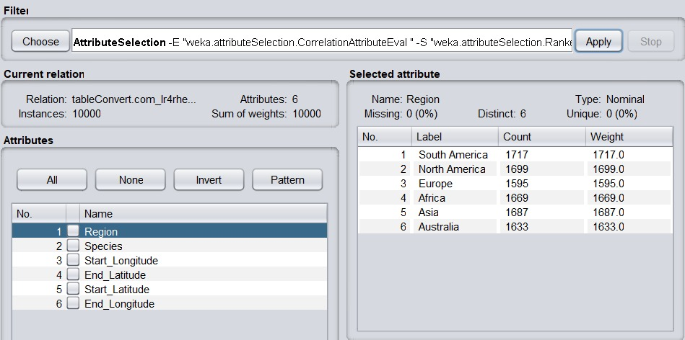
Fig no.4.16 After applying Attribute Selection for major migration hubs

7. What migration routes experience the highest success rates?
Target: Migration_Success
Supporting: Start_Latitude, Start_Longitude, End_Latitude, End_Longitude
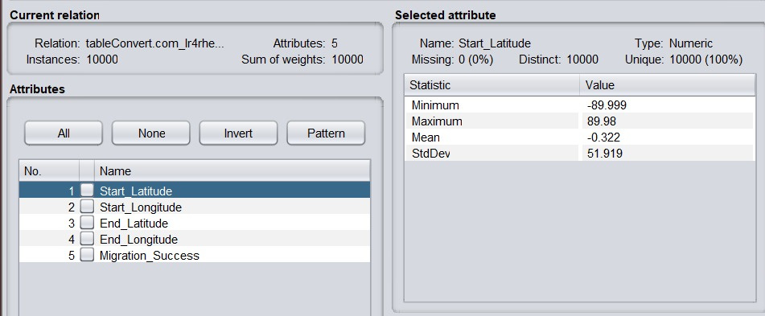
Fig no.4.17 Before applying Attribute Selection for migration routes experience the highest success rates
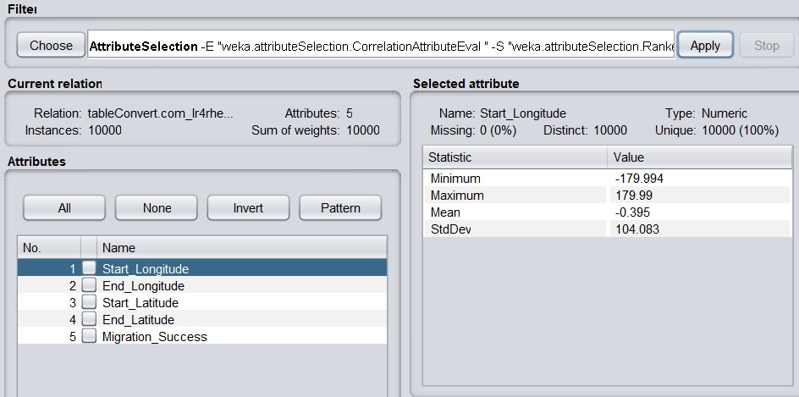
Fig no.4.18 After applying Attribute Selection for migration routes experience the highest success rates

8. Which origin–destination routes are most prone to migration failures?
Target: Migration_Success
Supporting: Origin, End_Latitude, End_Longitude, Interrupted_Reason
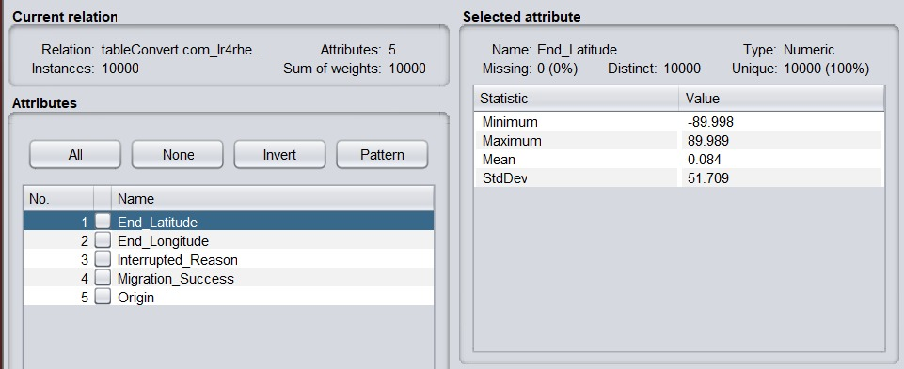
Fig no.4.19 Before applying Attribute Selection for origin–destination routes are most prone to migration failures
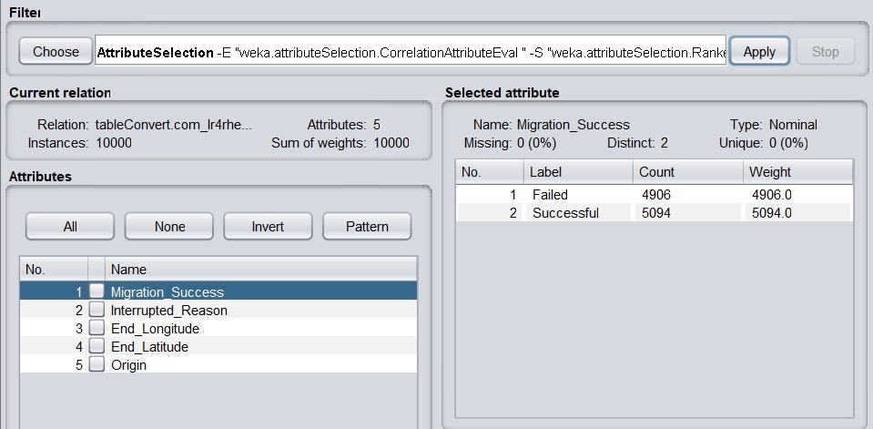
Fig no.4.20 After applying Attribute Selection for origin–destination routes are most prone to migration failures

9. How do geographic characteristics influence bird migration outcomes?
Target: Migration_Success
Supporting: Origin, Region, Habitat, Start_Latitude, End_Latitude
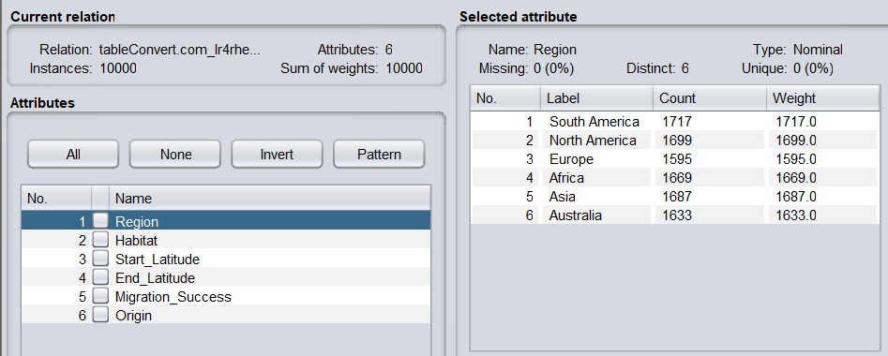
Fig no.4.21 Before applying Attribute Selection for do geographic characteristics influence bird migration outcomes
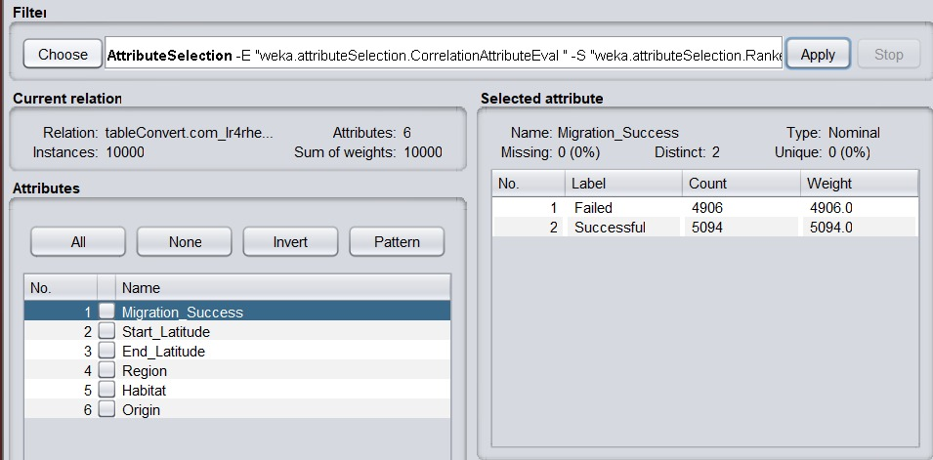
Fig no.4.22 After applying Attribute Selection for do geographic characteristics influence bird migration outcomes

10. Which locations function as both major origin and destination points in migration patterns?
Target: Origin, End_Latitude, End_Longitude
Supporting: Observation_Counts, Species
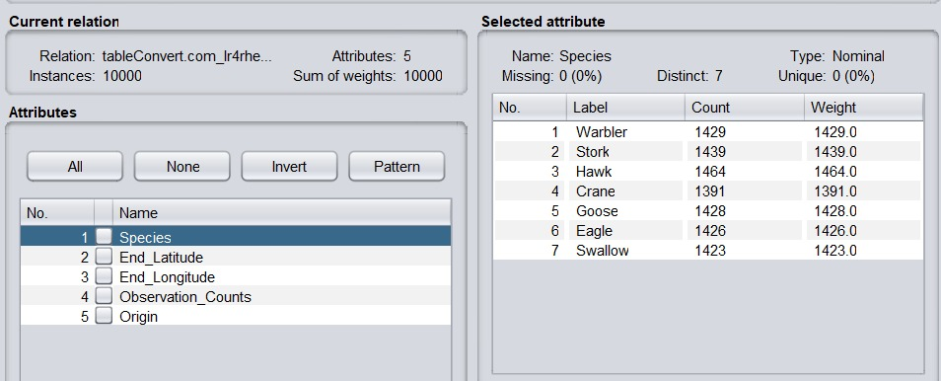
Fig no.4.23 Before applying Attribute Selection for locations function as both major origin and destination points in migration patterns
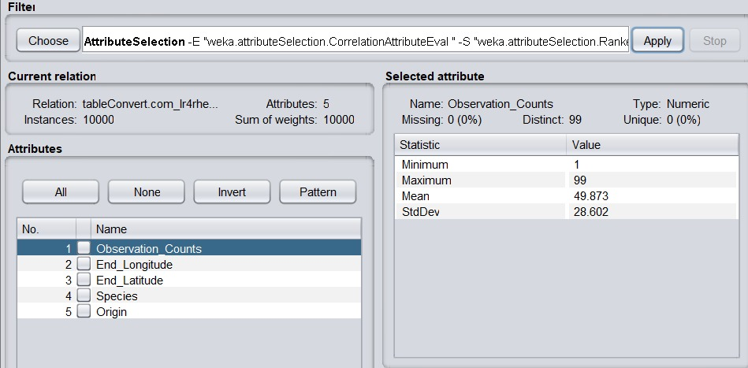
Fig no.4.24 After applying Attribute Selection for locations function as both major origin and destination points in migration patterns

11. How do migration success rates vary across different species?
Target: Migration_Success
Supporting: Species, Weather_Condition
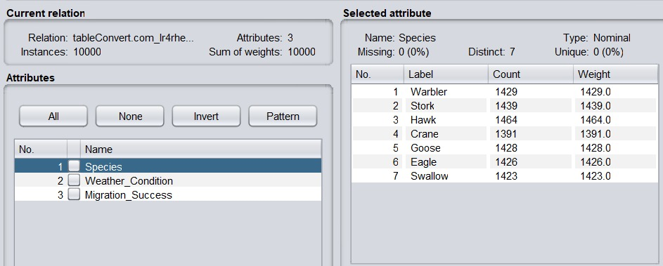
Fig no.4.25 Before applying Attribute Selection for migration success rates vary across different species
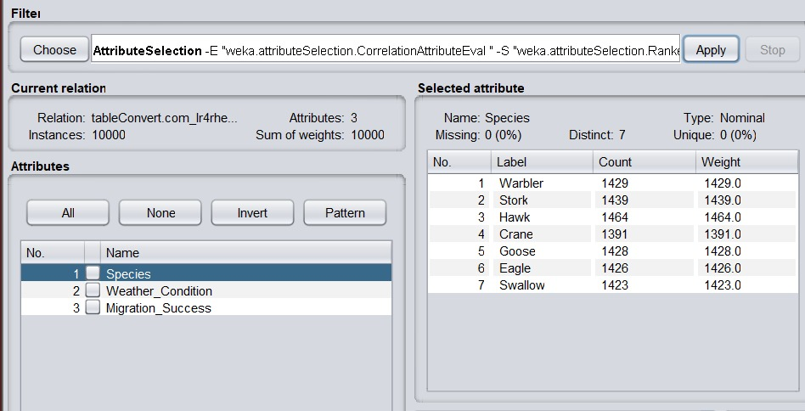
Fig no.4.26 After applying Attribute Selection for migration success rates vary across different species

12. Which weather show peak migration activity and why?
Target: Observation_Counts
Supporting: Wather_Cndition, Migration_Reason
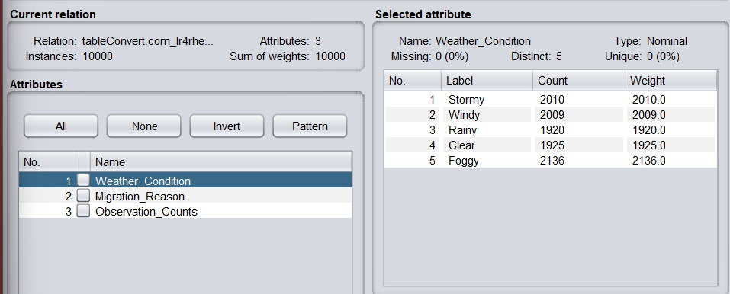
Fig no.4.27 Before applying Attribute Selection for weather show peak migration activity
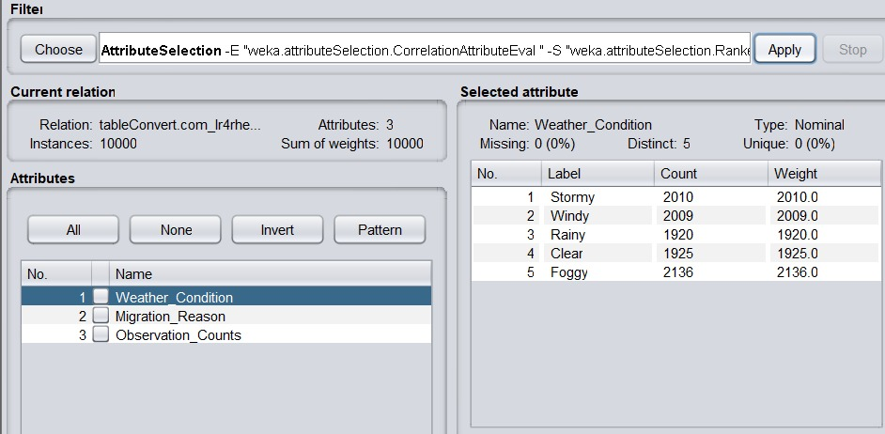
Fig no.4.28 After applying Attribute Selection for weather show peak migration activity

13. How have bird migration patterns changed over the years?
Target: Flight_Distance_km
Supporting: Species, Start_Latitude, End_Latitude
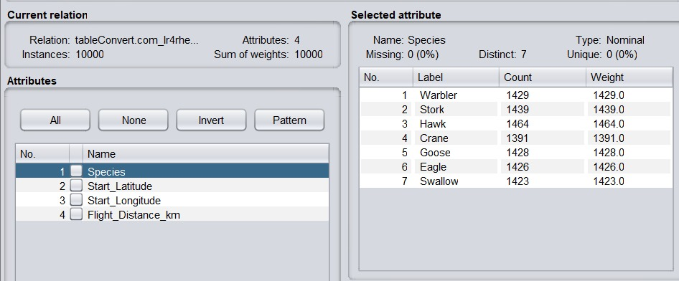
Fig no.4.29 Before applying Attribute Selection for migration pattern over years
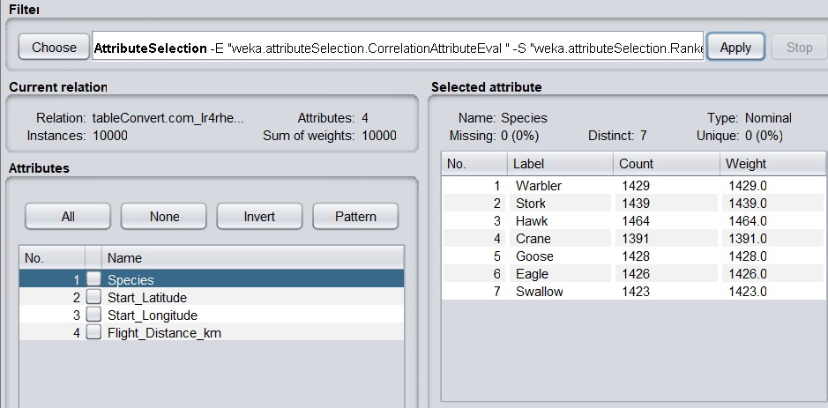
Fig no.4.30 After applying Attribute Selection for migration pattern over years

14. How do migration failures occur most across different weather?
Target: Migration_Success
Supporting: Interrupted_Reason, Weather_Condition
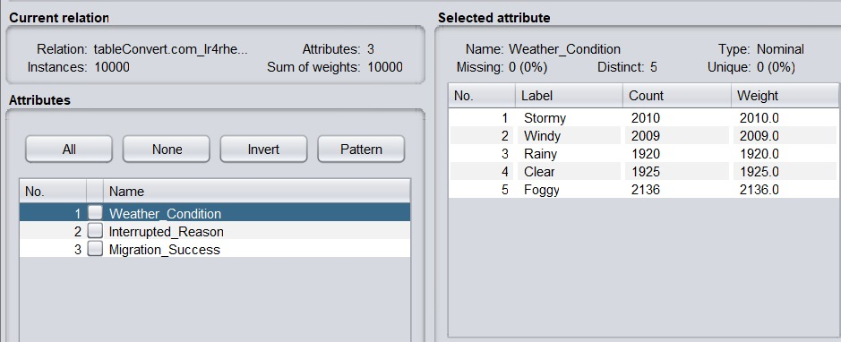
Fig no.4.31 Before applying Attribute Selection for Migration failures occur in different weather conditions
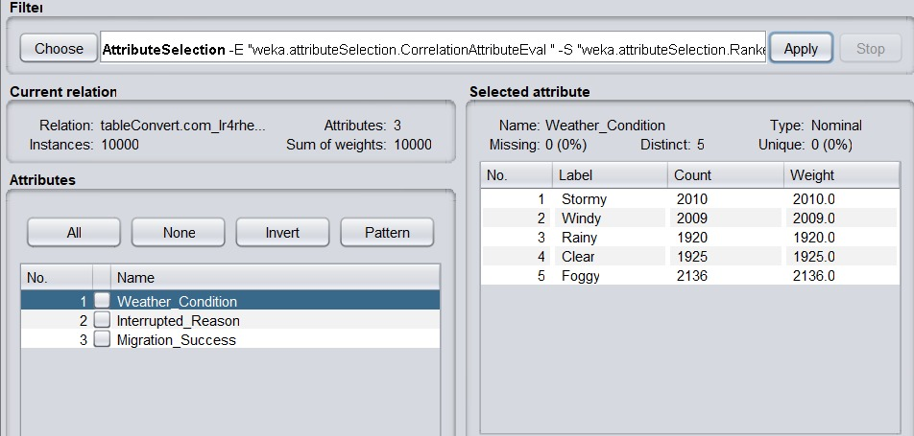
Fig no.4.32 After applying Attribute Selection for Migration failures occur in different weather conditions

15. Which species exist in migration distance and frequency?
Target: Flight_Distance_km, Observation_Counts
Supporting: Species
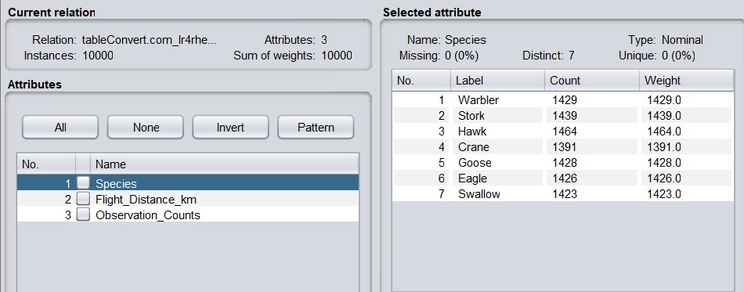
Fig no.4.33 Before applying Attribute Selection for species exist in migration distance and frequency
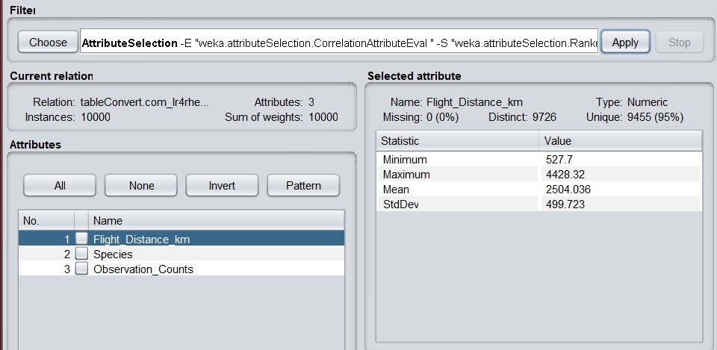
Fig no.4.34 After applying Attribute Selection for species exist in migration distance and frequency

16. Which bird species demonstrate the highest adaptability in their migration behavior?
Target: Migration_Success, Route variation
Supporting: Species, Habitat, Weather_Condition
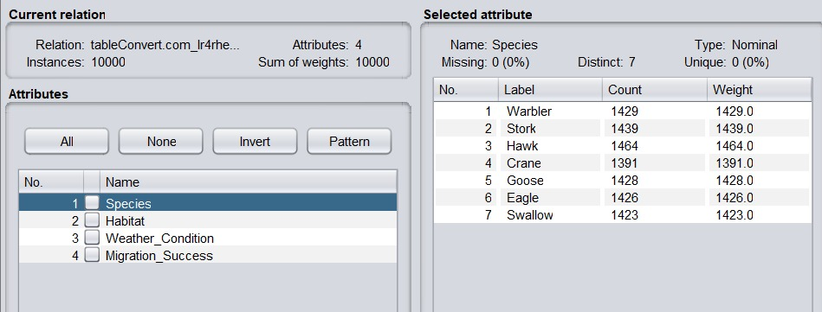
Fig no.4.35 Before applying Attribute Selection for bird species demonstrate the highest adaptability in their migration behavior
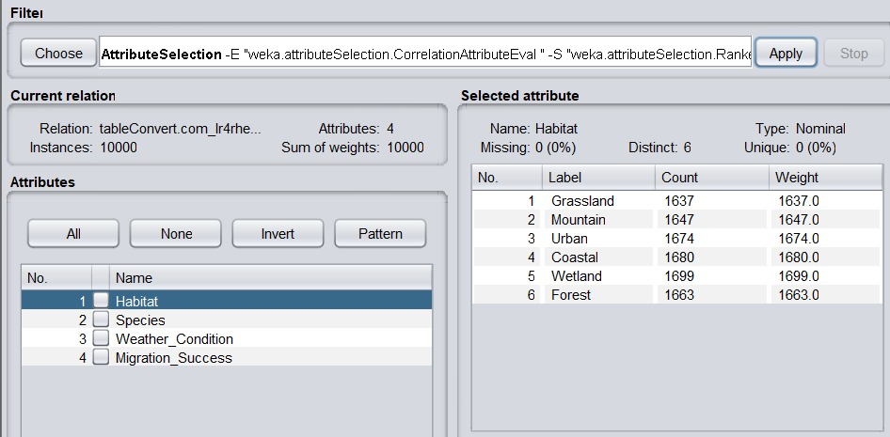
Fig no.4.36 After applying Attribute Selection for bird species demonstrate the highest adaptability in their migration behavior

17. How do environmental conditions impact migration success across species?
Target: Migration_Success
Supporting: Weather_Condition, Habitat, Species
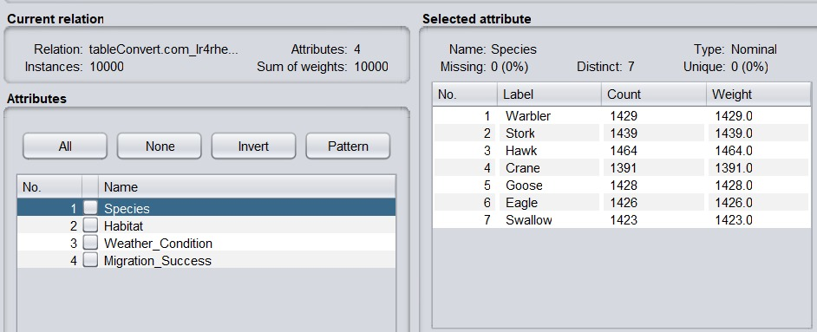
Fig no.4.37 Before applying Attribute Selection for do environmental conditions impact migration success across species
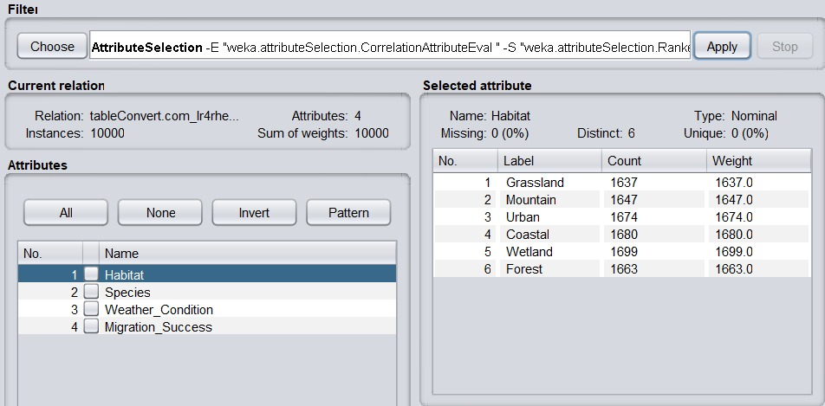
Fig no.4.38 After applying Attribute Selection for do environmental conditions impact migration success across species

18. What patterns distinguish short-distance migrations from long-distance migrations?
Target: Flight_Distance_km
Supporting: Migration_Success, Species, Habitat
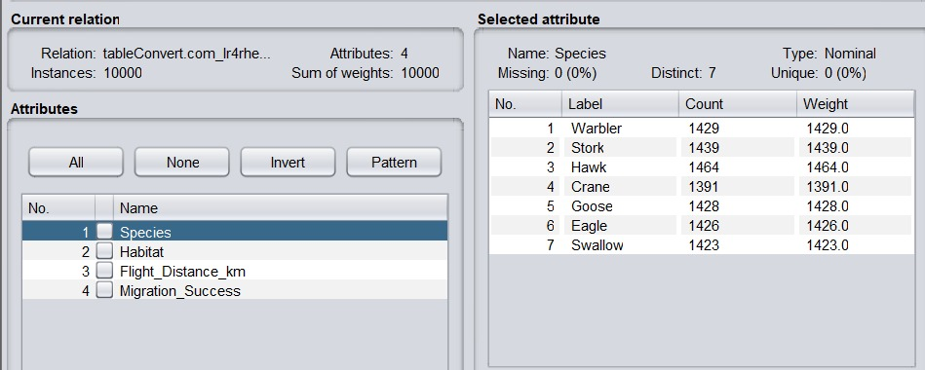
Fig no.4.39 Before applying Attribute Selection for distinguish short-distance migrations from long-distance migrations
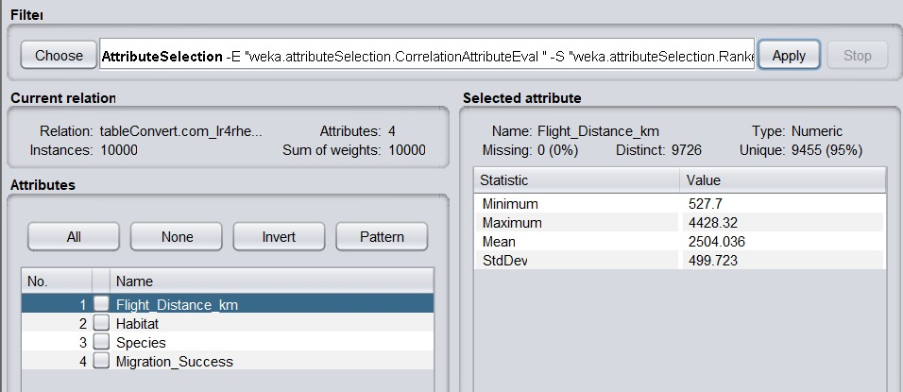
Fig no.4.40 After applying Attribute Selection for distinguish short-distance migrations from long-distance migrations

19. What common characteristics are observed in resilient migration routes?
Target: Migration_Success
Supporting: Weather_Condition, Habitat, Migration_Interrupted
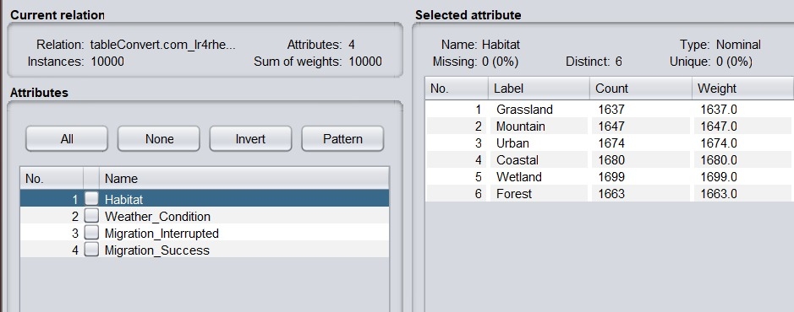
Fig no.4.41 Before applying Attribute Selection for common characteristics are observed in resilient migration routes
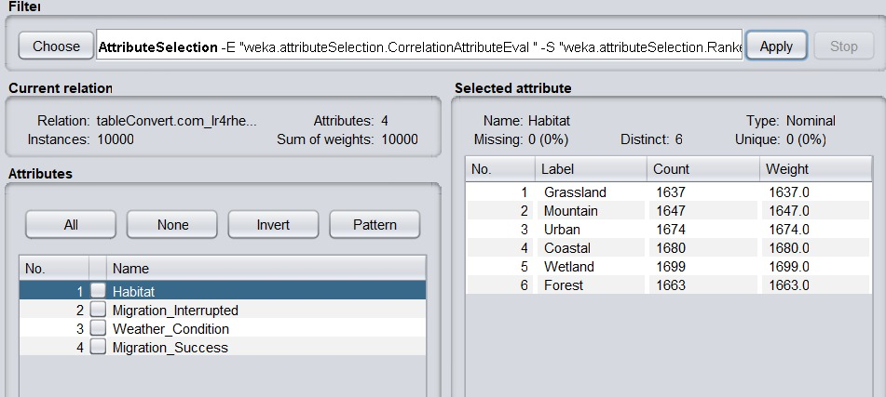
Fig no.4.42 After applying Attribute Selection for common characteristics are observed in resilient migration routes

20. Which species face the greatest migration challenges, and what factors contribute to these difficulties?
Target: Migration_Success
Supporting: Species, Interrupted_Reason, Weather_Condition, Migration_Distance_km
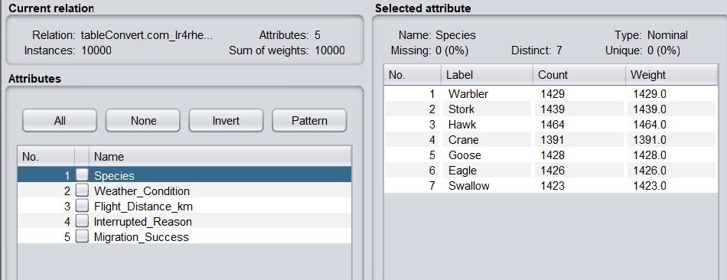
Fig no.4.43 Before applying Attribute Selection for species face the greatest migration challenges,
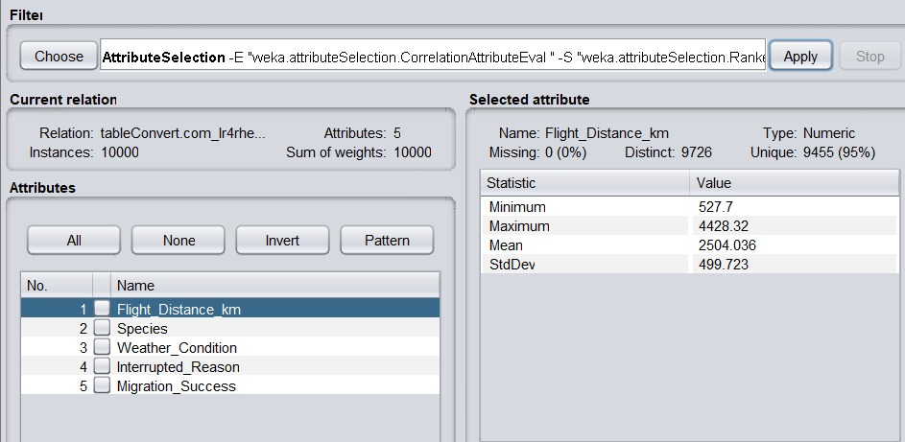
Fig no.4.44 Afte applying Attribute Selection species face the greatest migration challenges,
Step 4: Save Preprocessed Data :
After cleaning / normalization / visualization, save the preprocessed dataset by clicking on the "Save" button.

Problem Statement:
Statement 1: Analysis of Species-wise Bird Migration Behaviour
This project analyzes bird migration patterns using WEKA to understand the factors affecting migration success and failure. By examining species, migration distance, geographic locations, weather conditions, and habitats, the study identifies major migration routes, hubs, and challenges. The analysis helps in understanding migration behavior and improving ecological and conservation insights.

Result:
Thus, the data preprocessing operations such as data discretization and feature selection were performed using WEKA

